YARRABEE GARDEN & IRIS
PO Box 891 Ph: 0438817577
South Brighton SA 5048 Email: yarrabee.iris@bigpond.com

Website: www.yarrabeegardenandiris.com

ORDER FORM

YOUR DETAILS:
NAME:
ADDRESS:
P/C
PHONE NO: EMAIL:
In the event of one or more varieties being unavailable, please list preferred substitutes on reverse. If no preference is stated we will provide substitutes of equal or greater value in similar colour range to unavailable variety.

VARIETY | PRINTED TAGS (if reqd) | PRICE | QTY | TOTAL
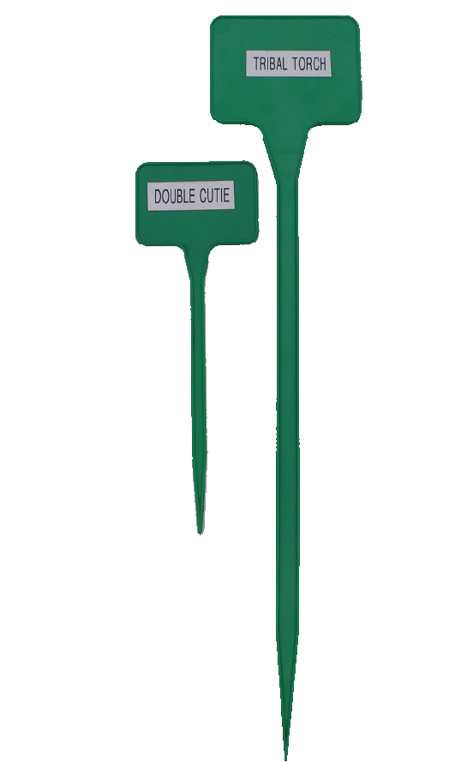  Budget Bag  30 cm  15 cm |  | $50
PLANT TAGS: | Sub Total this page
30cm printed - $1.50 ea | Sub total from page 2
15cm printed - $1.20 ea | Labels: ……..….(qty) @ $........... ea
30cm blank - $0.90 ea  15cm blank - $0.60 ea | + Postage, Handling - Eastern States $15 SA $12
 | TOTAL

PAYMENT METHOD:  Cheque  Money Order  Direct Deposit (please tick one)

Cheque or money order payable to Yarrabee Garden & Iris.
Direct Deposit to:
B Ward
BSB 105-071 A/c No. 035088840.
Please include your surname as reference. wix

VARIETY | LABELS  (tick if reqd) | PRICE | QTY | TOTAL
 |  | Page Total

My preferred substitutes would be:

